Multiple-Choice Test

Chapter 05.03

Newton’s Divided Difference Polynomial Method

- If a polynomial of degree has 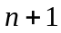 zeros, then the polynomial is
- oscillatory
- zero everywhere
- quadratic
- not defined

- The following 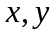 data is given.
 | 15 | 18 | 22
 | 24 | 37 | 25
The Newton’s divided difference second order polynomial for the above data is given by
The value of 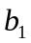is most nearly
- –1.0480
- 0.14333
- 4.3333
- 24.000

- The polynomial that passes through the following data
 | 18 | 22 | 24
 | ? | 25 | 123
is given by
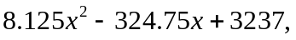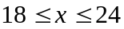
The corresponding polynomial using Newton’s divided difference polynomial is given by
The value of 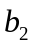 is most nearly
- 0.25000
- 8.1250
- 24.000
- not obtainable with the information given

- Velocity vs. time data for a body is approximated by a second order Newton’s divided difference polynomial as

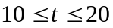
The acceleration in 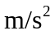 at 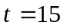 is
- 0.5540
- 39.622
- 36.852
- not obtainable with the given information

- The path that a robot is following on a 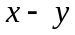 plane is found by interpolating the following four data points as
 | 2 | 4.5 | 5.5 | 7
 | 7.5 | 7.5 | 6 | 5
The length of the path from 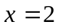 to 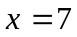 is

- 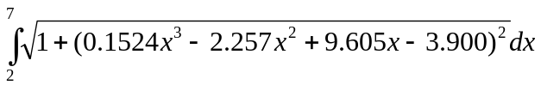
- 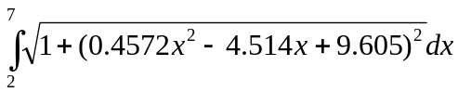
- 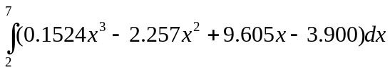

- The following data of the velocity of a body is given as a function of time.
Time (s) | 0 | 15 | 18 | 22 | 24
Velocity (m/s) | 22 | 24 | 37 | 25 | 123
If you were going to use quadratic interpolation to find the value of the velocity at 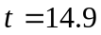 seconds, the three data points of time you would choose for interpolation are
- 0, 15, 18
- 15, 18, 22
- 0, 15, 22
- 0, 18, 24

For a complete solution, refer to the links at the end of the book.

